**Git and GitHub Notes**

**-by Naman Bhatia**

* Git is a Distributed Version Control System (VCS)

Example:

Agar maine ek folder banaya jiska name ABC that toh useke ander maine 3 file banaye let say f1, f2, f3 and bad main uska ek modified version banaya jisme f1= f0 se replace ho gaya then maine apne system main ek aur folder banay ya keh sakte hain ki maine kuch nahi kiya poora folder copy karke bas f1 ki jagaj f0 rakh diya.

Hua yeh ki maine apne system me jaagah jayada use ki hain, ise ko khatam karne ke liye Git aya.

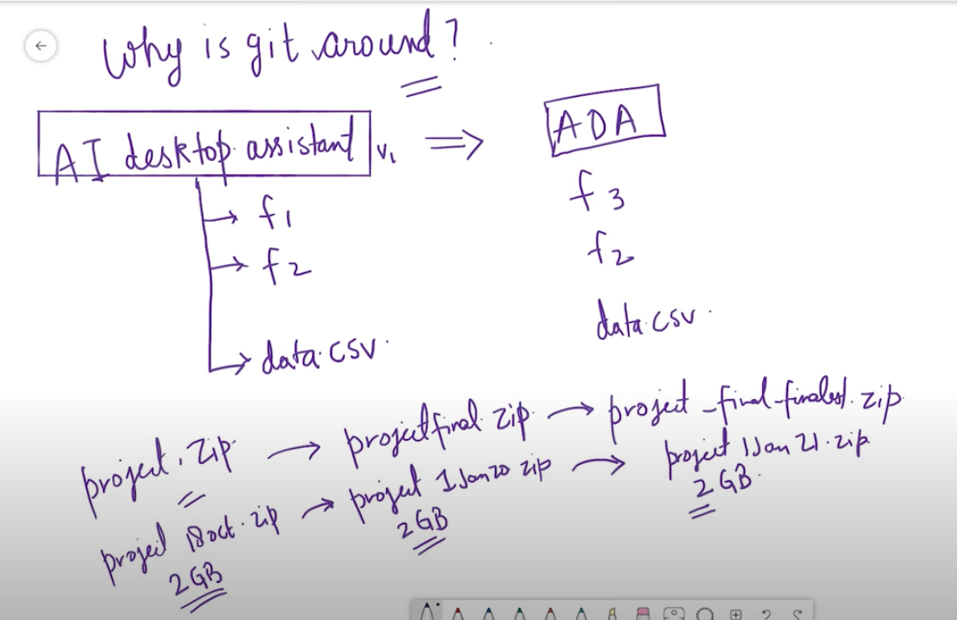

2gb *3 = 6 Gb data harddisk me aa gaya hain, so we need a version control which can handle situations like this ang GIT is made for same.

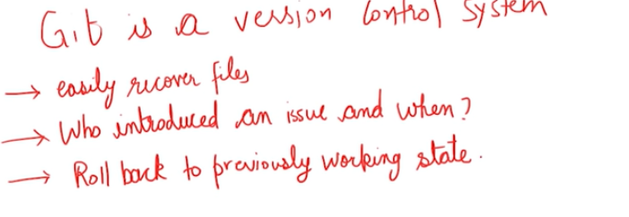

GIT HISTORY:

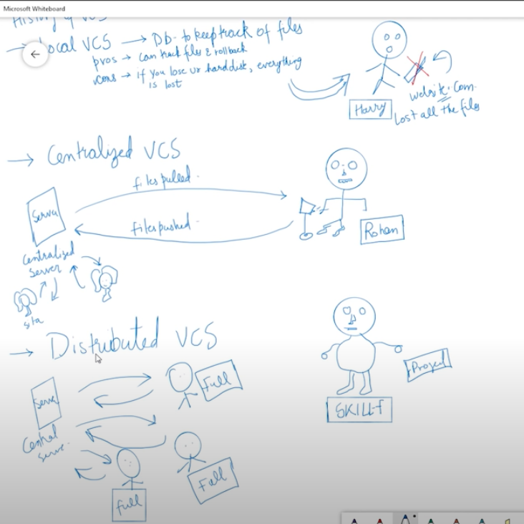

s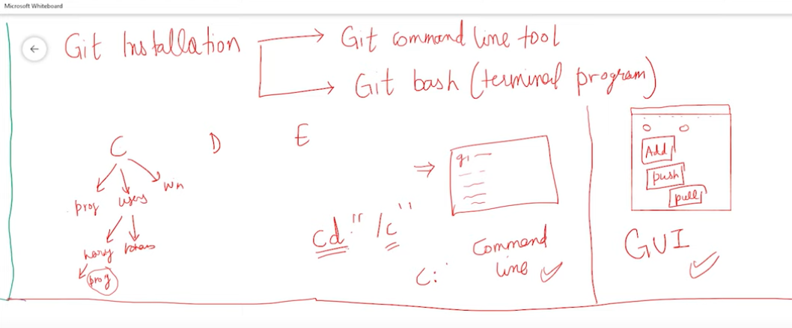

Cd: current directory